CHRIST (Deemed to be) UNIVERSITY

FRONT END UI/UX DESIGN FUNDAMENTALS

INTERIOR DESIGN STUDIO WEBSITE

And

DAILY JOURNELING WEBSITE

Submitted by :

CHRIS GEORGE THOMAS 2460347

TISHA PINHEIRO 2460465

VYSHAK S 2460474

Submitted on : 13 August 2025

INTERIOR DESIGN STUDIO WEBSITE

ABSTRACT

This project aims to design and develop a responsive webpage for an interior design studio, aimed at effectively presenting the studios aesthetic, services and portfolio to the clients. The primary goal was to design a visually engaging and user-friendly digital platform that reflects the studio’s creative identity while enhancing online visibility and client interaction. Built using the web technologies HTML and CSS, this site ensures seamless navigation across devices. The final outcome is a fully functional, aesthetically appealing website that serves as a valuable marketing and communication tool, allowing the studio to professionally display its work, attract new clients, and streamline service inquiries.

OBJECTIVE

The primary goals of this project were to:

* Design a user-friendly interface that aligns with modern UI principles, ensuring an intuitive and visually appealing user experience.
* Develop a fully responsive layout using only HTML and CSS, providing seamless performance and accessibility across various screen sizes and devices without relying on JavaScript or external frameworks.

SCOPE

The scope of this project encompasses the complete design and development of a static, fully responsive website for an interior design studio. The website aims to act as a digital portfolio and professional online presence that accurately reflects the studio's brand, aesthetic values, and range of services. It serves both as a marketing tool and an informational platform for potential clients.

Key areas covered within the project scope include:

1. Visual & UX/UI Design

2. Responsive Web Development

3. Content Structuring

4. Performance & Accessibility

5. Scalability & Maintenance Readiness

TECHNOLOGIES USED

* HTML - structure
* CSS - design
* VS code
* GitHub

HTML STRUCTURE OVERVIEW

* Used semantic tags: <header>, <nav>, <main>, <section>, <footer>.
* Structured into sections: **Home, About us, Services, Portfolio, Contact.**
* Different sections for living room, office room, kitchen designs.
* Navigation menu implemented using <ul> with anchor links for smooth scrolling.
* Image gallery for showcasing completed design projects.

## CSS STYLING STRATEGY

* External stylesheet style.css.
* Organized with comments and modular sections.
* Techniques used:
  + **Flexbox** and **CSS Grid** for layout.
  + **Media Queries** for responsiveness.
  + **CSS Variables** for color theme customization.
  + Hover effects for buttons and portfolio images.
  + Typography optimized for readability.

KEY FEATURES

| **Feature** | **Description** |
| --- | --- |
| Responsive Design | Adapts to all screen sizes with media queries. |
| Portfolio Gallery | Grid-based layout showcasing project images. |
| Smooth Navigation | Sticky navigation bar with smooth scrolling. |
| Contact Form | Includes input fields and validation via JavaScript. |
| Animated Elements | Fade-in and slide animations using JavaScript. |
| Theme Consistency | Custom color palette aligned with interior design aesthetics. |

CHALLENGES FACED AND SOLUTIONS

| **Challenge** | **Solution** |
| --- | --- |
| Images breaking layout on small screens | Used CSS Grid and responsive image sizing |
| Navigation overlapping content | Added sticky navbar with top padding adjustment |
| Contact form alignment issues | Used Flexbox to align form fields |
| Making animations smooth | Used requestAnimationFrame and CSS transitions |
| OUTCOME |  |

* Achieved a visually pleasing and functional front-end layout.
* Website is responsive across devices.
* Enhanced skills in HTML5, CSS3, and JavaScript.
* Learned practical web design techniques and responsive layouts.

FUTURE ENHANCEMENTS

* Add backend integration for storing form submissions.
* Implement image carousel for the portfolio section.
* Add a blog section for design tips.
* Include dark/light theme toggle.

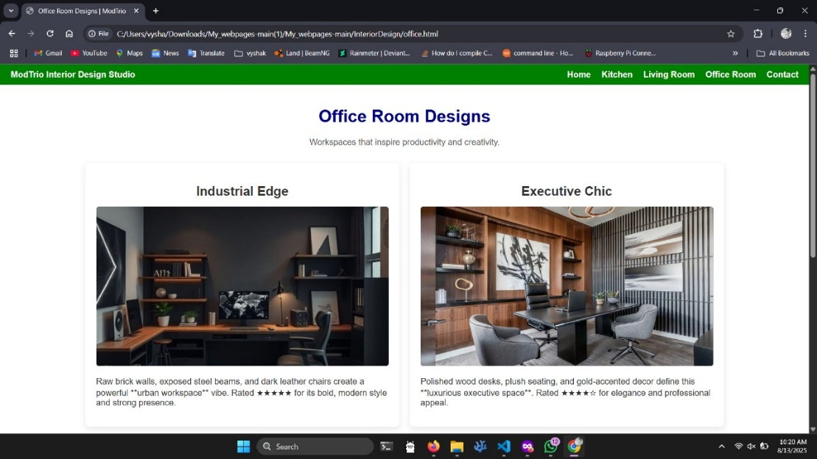SCREENSHOTS OF THE FINAL OUTPUT

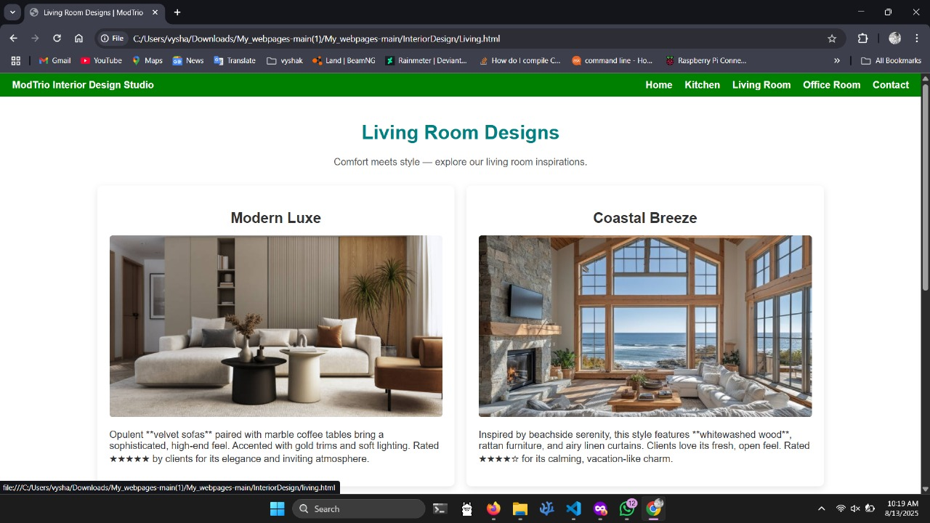

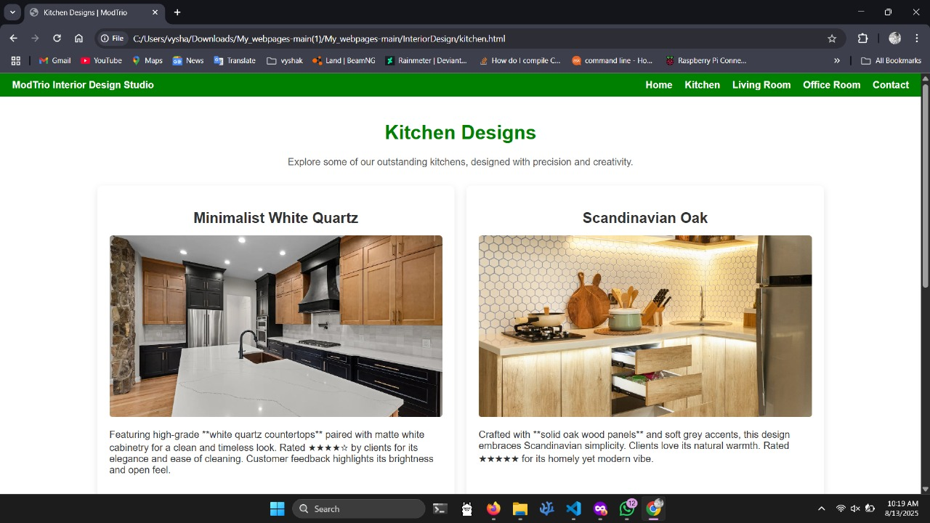



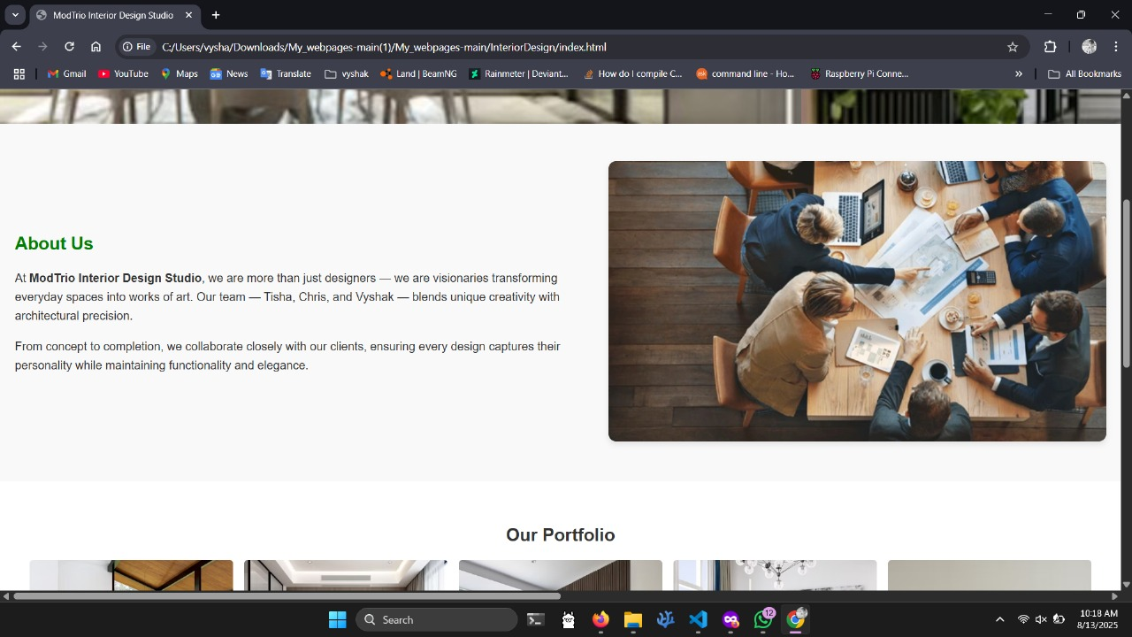

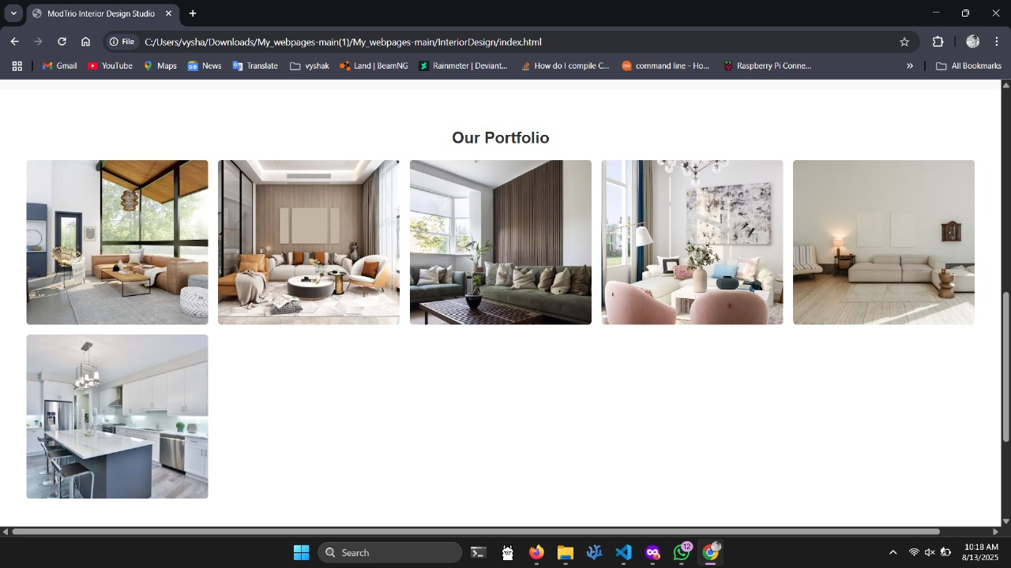

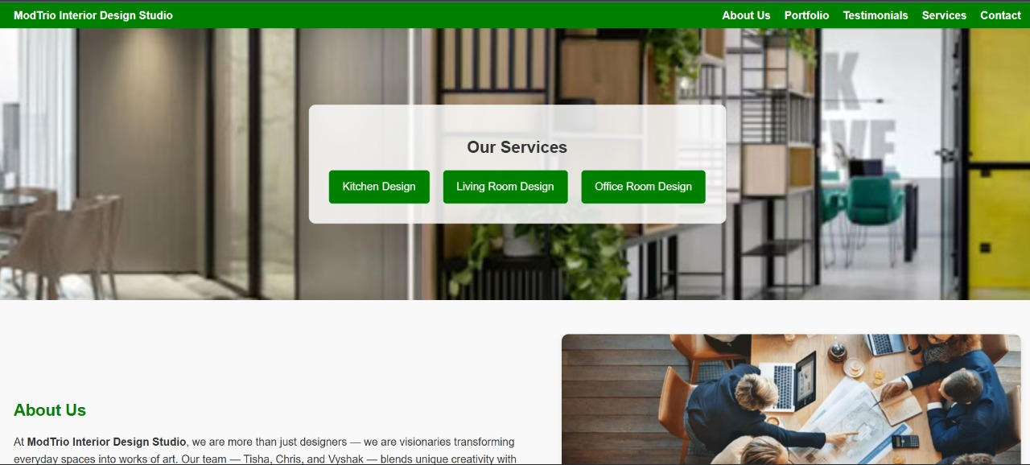

CONCLUSION

This project successfully delivered a **responsive and interactive website** for an interior design studio using only HTML, CSS, and JavaScript. The design highlights modern aesthetics, ease of navigation, and adaptability across devices. The development process deepened my understanding of responsive design, clean code structuring, and UI/UX principles.

DAILY JOURNELLING WEBSITE

ABSTRACT :

This project focuses on creating a responsive Daily Journaling Website using HTML and CSS. This design a visually appealing, easy-to-use, and responsive platform where users can write, store, and view journal entries in an organized layout. It caters to personal journal entries with archive functionality, mood tracking, and theme customization. Core technologies used include HTML for the structure and CSS for styling, layout, and responsive behavior. The final outcome is a well-structured, aesthetically pleasing journaling interface suitable for personal or educational use.

OBJECTIVES :

* Create a minimal yet attractive journaling platform.
* Design a user-friendly interface following modern UI/UX principles.
* Implement responsive design using HTML and CSS.
* Ensure content readability and accessibility across different devices.
* Maintain consistent branding and typography.

SCOPE OF THE PROJECT :

• Focused purely on front-end development.

• No JavaScript or backend storage included at this stage.

• Optimized for desktop, tablet, and mobile devices.

• Built entirely using open-source tools and pure HTML/CSS code.

TOOLS AND TECHNOLOGIES USED

HTML5 - Markup and content structure  
CSS3 - Styling and layout management  
VS Code - Code editor  
Chrome DevTools - Testing and debugging

HTML STRUCTURE OVERVIEW

* Semantic HTML tags such as <header>, <main>, <section>, <article>, <footer>.
* Organized sections for: Home, Journal Entries, Archive, Mood Tracker.
* Navigation bar with anchor links and fixed positioning.
* Column layouts for featured posts and recent entries.

### **CSS STYLING STRATEGY**

* External CSS file for maintainability.
* Nested Flexbox for main layout and comment threads.
* CSS Grid for archive and entry arrangement.
* Data attributes for mood tracker colors.
* CSS variables for theme management (light/dark mode).
* @media print rules for printable journal pages.

KEY FEATURES

| Feature | Description |
| --- | --- |
| Responsive Design | Adapts seamlessly to all screen sizes |
| Smooth Navigation | Fixed top navigation bar with anchor links |
| Journal Entry Cards | Clean, card-based design for easy browsing |
| Placeholder Contact Form | Layout for future user communication |
| Accessible Fonts & Colors | High contrast and legible typography |

### **CHALLENGES FACED AND SOLUTIONS**

| Challenge | Solution |
| --- | --- |
| Elements overlapping on small screens | Implemented responsive breakpoints with media queries |
| Alignment issues using float | Shifted to Flexbox and Grid layout |
| Font scaling problems | Used relative units (em/rem) instead of px |

OUTCOME

* Developed a clean, responsive journaling website layout.
* Achieved consistent UI with intuitive navigation.
* Strengthened understanding of responsive web design.
* All sections display correctly on various devices without JavaScript.

# FUTURE ENHANCEMENTS

* Add JavaScript for interactivity (saving and displaying journal entries dynamically).
* Backend integration for storing entries.
* Additional customization options for users.

# SCREENSHOTS OF FINAL OUTPUT

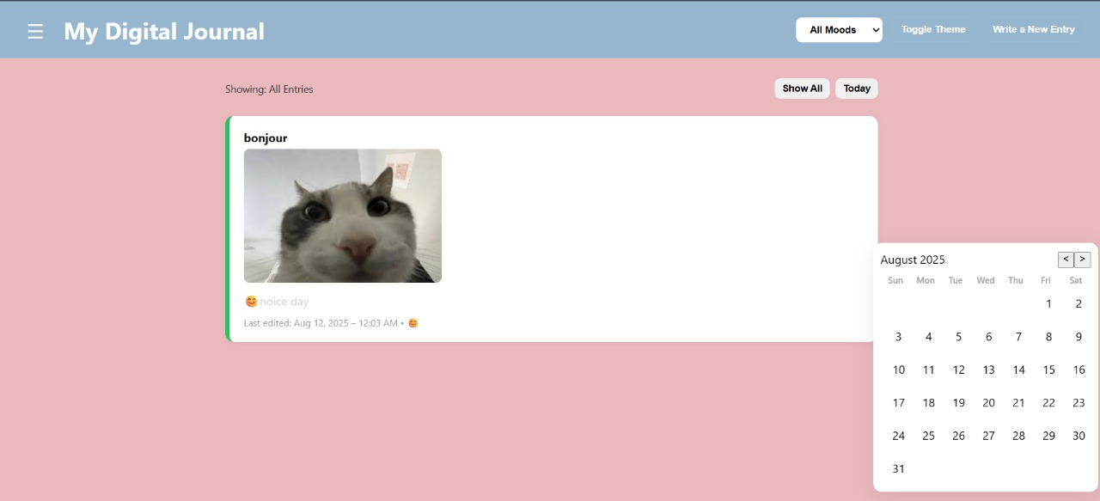

A dark and light themed webpage which the user can switch through seamlessly according to their preference.

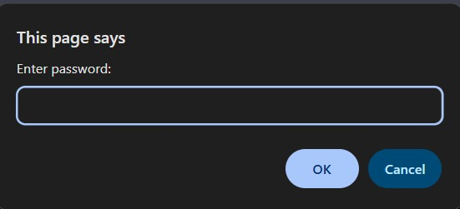

Password protection while accessing older entries.

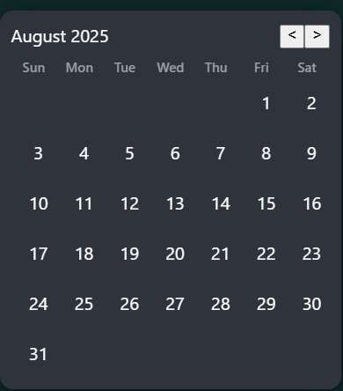

A calendar which indicates all the days you have been active (days which have entries) .



An interactive journaling template where we can add pictures and emoji to describe your feeling better.

# **CONCLUSION**

# Through this project we have learned to design and implement a user-friendly journaling platform using only HTML and CSS. The hands-on process improved my knowledge of layout structuring, responsive design, and visual aesthetics. I also gained a deeper appreciation for user-centric web design principles, which will serve as a foundation for future interactive and full-stack projects.